Task 2 – Security Alert Monitoring & Incident Response Simulation

Deliverable 1: Incident Response Report
Incident Report ID: IR-20250703-001
Date: 2025-07-03
Prepared By : Rohit Pawar
Status: CRITICAL

1. Executive Summary
On July 3, 2025, the Security Operations Center (SOC) detected a multi-stage, high-severity cyberattack. The attack involved a widespread infection of several malware types, including Trojans, Rootkits, and Spyware, which appears to have been a precursor to a final payload. At 09:10:14, a Critical alert for "Ransomware Behavior" was triggered on host 172.16.0.3, indicating an active, destructive attack.
Immediate containment and remediation are required to prevent further data encryption and operational downtime.

2. Incident Timeline & Key Alerts
Based on the "Logs Classification.pdf" log, the attack progressed as follows:
Timestamp | User | Source IP | Alert / Threat | Priority | Notes
2025-07-03 04:19:14 | alice | 198.51.100.42 | Rootkit Signature | High | Initial compromise. Rootkit signifies persistent, hidden access.
2025-07-03 05:06:14 | bob | 203.0.113.77 | Worm Infection Attempt | Medium | Evidence of attempted lateral movement to other systems.
2025-07-03 09:10:14 | bob | 172.16.0.3 | Ransomware Behavior | CRITICAL | Final payload deployed. Active data encryption likely in progress.

3. Key Findings & Evidence (SIEM Dashboard)
The "SOC Incident Dashboard.png" provides a clear summary of the incident.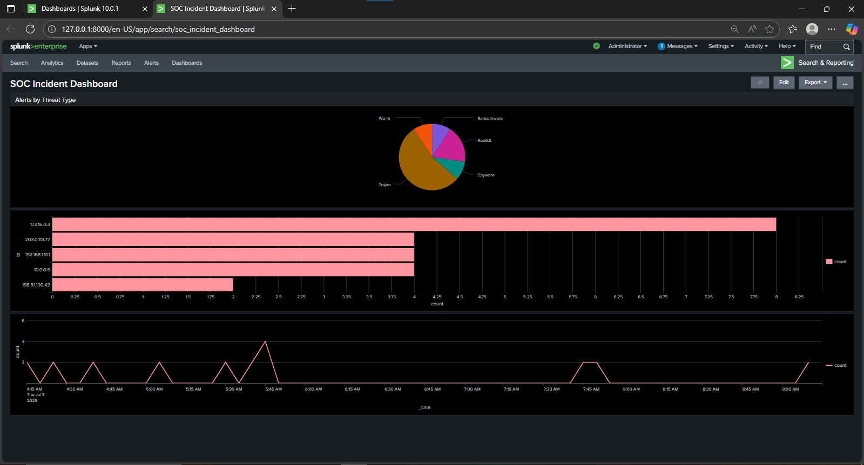
Analysis of this dashboard and other search results reveals three key findings:
- Multiple Threat Types: The "Alerts by Threat Type" panel shows a complex attack using several tools. The Threat Types.png screenshot confirms a variety of malware, including Trojans (5 alerts) and Rootkits (2 alerts), which were used to compromise the systems before the final ransomware payload.
- Top Affected IPs: The "Top Affected IPs" panel identifies 203.0.113.77, 172.16.0.3, and 198.51.100.42 as the primary hosts for malware activity. The "Top IP.png" screenshot confirms 172.16.0.3 is a key host to investigate.
- Suspicious Login Activity: The "Login Failed Top Users.png" screenshot shows that the user david had 3 failed login attempts.
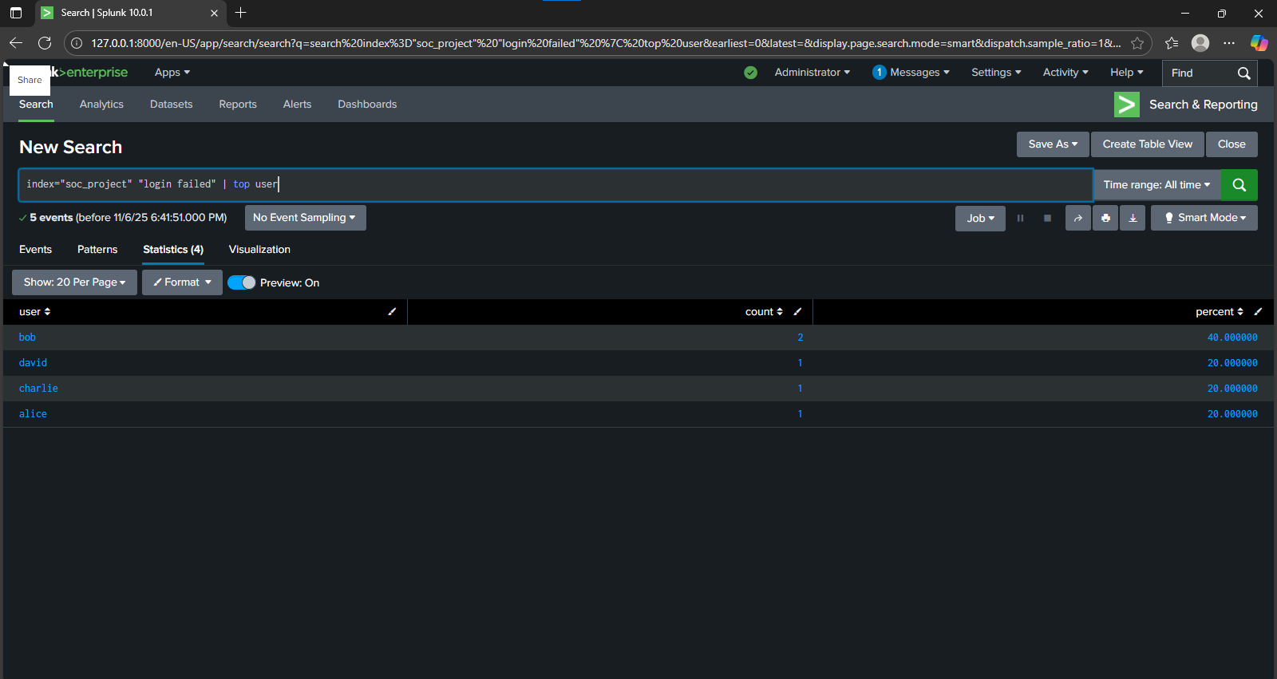While alice and bob had 1 failed login each, the activity for david is the most suspicious and could represent an attempted brute-force attack or a compromised account.

4. Impact Assessment
- Data: Critical. Active ransomware poses an immediate threat of data encryption and total loss. The presence of Spyware and Trojans indicates a high risk that data was exfiltrated before the ransomware was deployed.
- Systems: High. The detection of Rootkits means the affected systems (198.51.100.42, 10.0.0.5) are fully compromised. They cannot be trusted and must be rebuilt from scratch.
- Operations: Critical. The ransomware attack on 172.16.0.3 could spread laterally, halting business operations.

5. Suggested Remediation Plan

Phase 1: Contain (Immediate Actions)
- ISOLATE: Immediately disconnect the following IPs from the network to prevent the ransomware from spreading:
  - 172.16.0.3 (Ransomware host)
  - 198.51.100.42 (Rootkit host)
  - 10.0.0.5 (Rootkit host)
  - 203.0.113.77 (Worm host)

- LOCK ACCOUNTS: Temporarily disable all user accounts associated with critical alerts: bob, alice, eve, david, charlie.

Phase 2: Eradicate
- FORENSICS: Take a forensic snapshot (disk and memory image) of host 172.16.0.3 for further investigation before wiping it.
- RE-IMAGE: Wipe and re-image all affected machines from a known-good, trusted build. Do not attempt to "clean" the systems—the rootkits make this unsafe.

Phase 3: Recover
- RESTORE: Restore encrypted data from the most recent, verified-clean, offline backups.
- RESET PASSWORDS: After all systems are confirmed clean, force a mandatory password reset for all involved users.
- SCAN: Conduct a full network vulnerability scan to identify the initial access vector (e.g., phishing, unpatched software) that allowed the attack to succeed.

